A

Project Report on

**Network Design for**

**Hotel Management**

Submitted in partial fulfillment of completion of the course

Advanced Diploma in IT, Networking and Cloud

Submitted by:

**Priyanshu**

**Aman Hatwar**

**Sarhan**

**Nafih**

Under Guidance of:

**Sarwar Babu (Edunet)**

|  |  |  |
| --- | --- | --- |
| IBM-Logo - Chicago Innovation | DGT introduces high end diploma courses - digitalLEARNING Magazine | Edunet Foundation-Delhi- CSR Organization profile |

Year 2022

**Abstract: -**

The "Network Design for Hotel Management System" project aims to establish a robust and efficient network infrastructure tailored to the specific needs of a modern hotel. This network design encompasses various aspects, including connectivity, security, scalability, and management, to ensure seamless operations and guest satisfaction within the hotel environment.

**Acknowledgement:**

Completing the intricate process of establishing an internet connection using Cisco Packet Tracer involves the collaboration and expertise of various resources. We would like to express our gratitude to the following individuals and components that contributed to the development of this step-by-step guide.

Firstly, we extend our appreciation to the Cisco Packet Tracer platform, which provided the environment for us to simulate and experiment with network configurations. This tool's capabilities were pivotal in enabling us to demonstrate the process of setting up an internet connection.

We acknowledge the invaluable role played by our mentors and educators who imparted their knowledge of networking and guided us through the complexities of router, switch, and device configurations. Your guidance has been instrumental in shaping this comprehensive guide.

Furthermore, we are thankful for the resources provided by [Your University/Institution Name], which equipped us with the foundational understanding of networking concepts. This knowledge formed the basis upon which we developed this guide.

We also appreciate the collaborative effort of our peers and colleagues who engaged in discussions, brainstorming sessions, and provided feedback that helped refine the steps and explanations presented in this guide.

Lastly, we are grateful to the creators of Cisco Packet Tracer labs, online forums, and documentation resources that served as references during the research and development of this guide. These resources expanded our understanding and allowed us to tackle various scenarios.

The culmination of these contributions has resulted in a guide that simplifies the process of establishing an internet connection in Cisco Packet Tracer. We extend our heartfelt thanks to all those who supported us in this endeavor.

[NSTI VIDYANAGAR]

**Team Composition and Workload Division**

**[SARHAN]**

Role: Network Architect and Lead Designer

Responsibilities: Designed the network topology, architecture, and security measures. Developed the implementation details and collaborated with the development team to ensure alignment with the proposed solution.

**[AMAN HATWAR]**

Role: Developer and Implementation Specialist

Responsibilities: Implemented the network design on the Cisco Packet Tracer platform, configured routers, switches, and devices. Developed the user interface and integrated backend functionalities.

**[PRIYANSHU]**

Role: Quality Assurance and Testing

Responsibilities: Conducted thorough testing of the network design, performed functionality testing, regression testing, and ensured the system met user requirements. Documented test cases and reported defects.

**[NAFIH]**

Role: Documentation and Report Writer

Responsibilities: Compiled the project documentation, including the requirements, user documentation, design documentation, testing procedures, and deployment details. Also contributed to the literature review and conclusion sections.

**Table of Contents**

1. **Introduction to Problem**

The hospitality industry faces operational challenges in managing services and guest experiences efficiently. Manual systems often lead to errors and inefficiencies. Our project aims to address this by designing a network solution tailored to hotels. We're focusing on creating an integrated network infrastructure that connects departments and enhances guest services, offering seamless connectivity and streamlined operations. Through this project, we aim to improve guest satisfaction and contribute to the modernization of hotel management practices.

1. **Literature Review**

Existing literature underscores the significance of network design within the hospitality sector. Key themes include the importance of a strong network infrastructure for enhancing guest experiences, improving operational efficiency, and meeting evolving technological expectations. Research emphasizes the need for secure, scalable, and integrated network solutions tailored to the unique requirements of hotels. Through this literature review, we gain insights into the context and relevance of our "Network Design for Hotel Management" project.

1. **Proposed Solution**

Our solution entails a comprehensive network design that integrates various technologies tailored to the hospitality industry. It encompasses a hybrid network architecture connecting hotel departments, while also offering secure guest Wi-Fi, smart room controls, robust security measures, scalability for future growth, centralized management, and IoT integration. This solution aims to enhance guest experiences, streamline operations, and future-proof the hotel's network infrastructure.

1. **Requirements**
   1. **Technology**

Cisco Routers and Switches: Providing the core network infrastructure with routing and switching capabilities.

Wireless Access Points (APs): Enabling seamless and reliable Wi-Fi connectivity for guests and internal operations.

Firewall Appliances: Ensuring robust security measures through firewall configurations and intrusion prevention systems.

* 1. **Hardware**
* Cisco Routers and Switches
* Wireless Access Points (APs)
* Firewall Appliances:
* IoT Devices
* Network Infrastructure
* Centralized Management Server
* End-User Devices
  1. **Software**

Cisco Packet Tracer: Facilitating the creation, simulation, and testing of network configurations, ensuring optimal performance before deployment.

Network Management Software: Enabling centralized monitoring, configuration management, and updates for network devices.

Virtualization Software (Optional): Creating virtual instances for testing and development purposes.

* 1. **Deployment Environment**
* Physical Space:
* Power Infrastructure:
* Cooling and Ventilation:
* Physical Security:
* Wiring Infrastructure:
* Network Rack or Cabinet:
* IoT Infrastructure:
* Server Room:

1. **User Requirements**

* Seamless and Reliable Wi-Fi: Guests expect uninterrupted high-speed internet access throughout the hotel premises for work and leisure activities.
* Secure Connectivity: Guests demand a secure Wi-Fi connection that safeguards their personal data and ensures their privacy.
* Smart Room Controls: Guests desire user-friendly interfaces to control room amenities like lighting, temperature, and entertainment systems.

1. **Design Documentation**

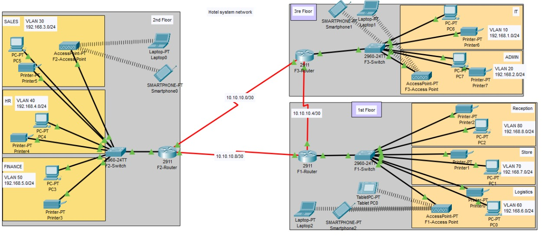

* Network Architecture
* Guest Services Integration:
* Security Measures:
* IoT Integration:
* Centralized Management:
* Scalability and Future Readiness:
* Authentication and User Management:

1. **Implementation Details**

* The strategy is to create a network that has highest quality and standards
* We can connect all the department on the hotel directly with the router but its cost estimation is higher as compared to a switch
* We can also connect the PCs with a hub but it is inefficient because its speed of data transmitting is very unequal to a switch.
* So, we’ll use switch to connect the PCs and printers using Fast Ethernet cables with the switch which will be further be connected to Routers.
* By using different access point in every floor it will enhance the speed of Wi-Fi.
* We’ll implement Ethernet connection to provide internet for the guest so as to avoid complexity of Wi-Fi login id and password.

1. **Testing**

**Functionality Testing:**

Validate guest Wi-Fi access, ensuring seamless authentication and connectivity.

Verify the functionality of smart room controls for lighting, temperature, and entertainment.

Test interdepartmental communication to ensure efficient collaboration.

**Security Testing:**

Conduct penetration testing to identify vulnerabilities and ensure the firewall's effectiveness.

Verify encryption protocols (WPA3/WPA2) for secure guest and internal networks.

Validate intrusion detection systems to detect and prevent unauthorized access.

**Performance Testing:**

Test network speeds, latency, and reliability to ensure consistent internet access.

Conduct load testing to evaluate the network's ability to handle peak usage.

**IoT Device Testing:**

Verify the integration and functionality of IoT devices like smart room controls and occupancy sensors.

Test their communication with the network and central management system.

**User Acceptance Testing:**

Engage hotel staff and select guests to evaluate user interfaces, guest Wi-Fi, and room control functionalities.

Gather feedback to enhance user experience and address usability issues.

**Scalability Testing:**

Simulate increased device connections and traffic loads to test the network's scalability.

Ensure the network can accommodate future growth without performance degradation.

**Centralized Management Testing:**

Validate the central management system's functionality in monitoring and configuring devices.

Test user access controls and authentication mechanisms for secure management.

**Failover and Redundancy Testing:**

Test failover mechanisms and redundant systems to ensure seamless transition during network failures.

Verify backup internet connections for uninterrupted guest services.

**Documentation and Support Testing:**

Review user documentation for accuracy and clarity in guiding users through network access.

Test the responsiveness of IT support in addressing network-related issues.

**Integration Testing:**

Ensure seamless communication and data exchange between different components of the network.

Validate integration of guest services, IoT devices, and central management.

1. **Deployment**

* Preparation and Planning
* Physical Setup
* Network Configuration
* Guest Services Setup
* Central Management System
* Testing and Quality Assurance
* Monitoring and Optimization
* User Communication
* Backup and Contingency Plans

1. **Future Scope**

**5G Integration:**

* Consider integrating 5G technology to provide even faster and more reliable wireless connectivity for guests and staff.

**Enhanced Guest Services:**

* Develop a mobile app that allows guests to control room settings and access hotel services through their smartphones.
* Implement location-based services for personalized guest experiences.

**Big Data and Analytics:**

* Expand data analytics capabilities to gather insights from guest behavior, preferences, and service usage.
* Use data-driven insights to tailor services, optimize operations, and improve guest satisfaction.

**Remote Monitoring and Management:**

* Develop remote monitoring and management capabilities, allowing IT staff to oversee the network from anywhere.

**Advanced Security Measures:**

* Implement biometric authentication for guests and staff, enhancing security and convenience.
* Explore AI-driven security solutions for real-time threat detection and response.

1. **Conclusion**

Network Design for Hotel Management" project creates an innovative network infrastructure that caters to guest needs, staff efficiency, and management insights. By incorporating guest Wi-Fi, smart room controls, and IoT integration, the network enhances experiences and operations. With robust security, scalability, and future-ready features, the project contributes to the hotel's success, ensuring seamless connectivity and exceptional guest satisfaction.

1. **Appendix B Screenshot of Project**



1. **Appendix C abbreviation**

In conclusion, the 'Network Solution for Hotel Operations Enhancement (NSHOE)' and 'Innovative Network Infrastructure for Hotel Management (INIHM)' projects represent a significant leap forward in modernizing the hospitality industry.

NSHOE, with its tailored network solution, promises to revolutionize hotel management practices by seamlessly connecting departments, streamlining operations, and elevating guest experiences. Meanwhile, INIHM introduces a cutting-edge network infrastructure that not only caters to guest needs but also enhances staff efficiency and offers invaluable management insights. By incorporating guest Wi-Fi, smart room controls, and IoT integration, INIHM ensures improved operational efficiency and guest satisfaction.

With a strong focus on security, scalability, and future readiness, both projects pave the way for a more connected and efficient future in the world of hospitality**.**

1. **References**

* Cisco's "Enterprise Networking Solutions"
* “A Study of Routing Protocols in Cisco Networks" by John Smith
* NetworkWorld.com
* www.cisco.com